WORK PRCEDURE FOR EGBW 3 WELL BORE CLEAN UP
APRIL , 2015

TABLE OF CONTENT
- OBJECTIVE OF PROJECT
- SCOPE OF WORK
- WELL HISTORY
  - WELL DATA
- HSE PLAN
- WELL BORE CLEAN-UP PROCEDURE
- EXECUTION REQUIREMENT/PLAN
  - EQUIPMENT REQUIREMENT
  - PERSONNEL REQUIREMENT
  - CHEMICAL REQUIREMENT
APPENDIX 1: WELL COMPLETION SCHEMATICS
APPENDIX 2: RIG UP SCHEMATICS

1.0 OBJECTIVE OF PROJECT
The objectives of the well bore clean-up operations are to:
- Unload the well (two reservoir zones) of all completion fluids/solids
2.0 SCOPE OF WORK
- Mobilise equipment and personnel to site
- Rig up equipment to well head
- Carry out wellbore clean out
- Rig down equipment and demobilize CT spread

3.0 WELL HISTORY
The Egbema field lies within the Niger Delta depobelt which is characterized by simple rollover anticlinal structures with thick continental and paralic sediments. The Egbema structure is a fault-assisted rollover anticline formed on the downthrown side of a major fault. The Egbema field is in trend with Oguta, Ahia and Ebocha fields.
Egbema field reservoir maps are being re-processed from 2D to 3D. Data Acquisition carried out in 2013 & 2014 have provided more information on the saturations in the D8.0 & G1.0 Reservoirs. Following a recent field review and optimization study, a number of wells were identified for re-opening/re-completion which included EGBM 3L/S.

The well was completed in May 1967 as a TSD oil producer on the G1.00 and G1.002 sands without top packer and SCSSV. Both intervals were consolidated for sand control purposes. The upper interval produced up to a maximum rate of 3,000bopd with a gradual increase in sand production that subsequently led to choke size reduction in April in 1972. The attempt to re-consolidate this interval on the short string with eposand in 1990 was not successful. The production tubing and the annulus were confirmed plugged with epicote after the chemical consolidation operation. This interval (producing from the short string) was therefore closed in for epicote obstruction.

The long string interval quit in 2000 where the nitrogen lifting activity of May 2003 confirmed that the interval has watered out because it produced 100% water throughout the two-day lifting period. RST shows that the long string perforations are completely flushed while oil saturation is present in the short string. The Well was secured with a PXN plug and NRV in May 2006. The last production test in March 2000 shows production of 1640blpd, GOR 924scf/bbl, BSW 29% and THP 760psi on bean 32/64”. The re-completed EGBM 3L/S is expected to increase recovery from the D8.0 & G.0 sands by 1,200 bpd.

3.1 WELL DATA
COUNTRY | NIGERIA, ONSHORE
OPERATOR | NPDC
CONCESSION | OML 20
FIELD NAME | EGBEMA
WELL NAME | EGBM 3
LOCATION | LAND
CLASSIFICATION | DEVELOPMENT/RE- COMPLETION
CO-ORDINATES | X: 477882.16m EY: 171460.63m N
DRILIING RIG/CONTRACTOR | DURGA 3
COMPLETION RIG/CONTRACTOR | HALLIBURTON
RTE | 36.5ft
TOTAL WELL DEPTH | 8,120ft (MD)
MAXIMUMDEVIATION | 2.00⁰
DRILLING COMPLETED | 17/05/1967
- HSE PLAN

- The NPDC Supervisor has the single point responsibility for this job and will communicate
role description prior to the job for proper supervision.
- Before mobilization, an initial site visit should be made by the field supervisor to ascertain the likelihood of other operations that may occur simultaneously with the programme activity (e.g. flowing well in the same cellar or adjacent cellar or site being used as a thoroughfare) and this should be properly captured in the JHA as concurrent operations.

- Before any work commences, the correct work permit will be completed in accordance with Permit to Work procedures.

- Before any work commences, the Site Supervisor shall hold safety meeting with all personnel involved in the job (discuss access control, job procedure, job potential hazards and precautions, safety equipment, smoking area, HAC etc.). Pre-job safety meetings must be documented.

- Security evaluation and assessment of area should be reviewed regularly and updates and/or changes are to be communicated to the NPDC Supervisor and NPDC security team.

- Pre-mobilization equipment audit to be undertaken by NPDC Supervisor ensuring that all pressure equipment (chiksans, Xmas tree adapters, wireline lubricator assemblies, BOPs etc.) have valid test certification and test bands indicating ID equipment numbers, current test dates and test pressures. Only equipment audited should be used on location unless otherwise notified, audited and agreed with the NPDC Supervisor.

- Only certified Vehicles are to be used to transport personnel & equipment to and from
NPDC locations and should adhere to NPDC No night sailing policies.
- Daily tool box talk /Safety meeting to be held on site prior to commencement of the day’s job detailing;
    - Job Objectives
    - Work Plan & Methods
    - Roles & Responsibilities
    - Access & Evacuation
    - Hazards, Controls & Contingencies
    - Equipment & Materials
    - Conflicting Activities
    - Job Hazard analysis for the day’s activity
    - Concurrent Operations Issues

- General safety practices for Completions & Well Intervention operations to apply

- Only 1502 WecoChiksans are to be used for hooking-up all pumping lines.

- All Pressure equipment (chiksans, Xmas tree adapters, wireline lubricator assy, etc) must have valid test certificates appropriate to the well conditions (ie. pressure rating of 5,000psi and type of service) and also has test bands indicating test pressures/dates.

- All pressure tests are to be done for a minimum duration of 15 minutes.

- All equipment are to be positioned in line with equipment spotting chart to recognise hazardous area classification (HAC) – See the Site Specific HSE Plan for this operation (this forms an intrinsic part of this job program)

- All equipment on location MUST be fitted with spark arrestor.

- Material Safety Data Sheets (MSDS) or SHOC cards of all chemicals to be used for this operation must be made available onsite and kept in a clear area known to work crew.

- Barriers and Warning signs/notices shall be erected instructing all non-essential personnel to stay clear of the area.

- Gas testing should be conducted at regular intervals (hourly) and results adequately Documented.

- At least 4 pcs x 9Kg Fire extinguishers should be available and located at a central access point during this operation.

- Carry out Fire/Abandonment and Medical evacuation drills after rig up of equipment prior to commencing activity. Document the drills conducted.

- Functional eye shower & eye wash bottles MUST be made available and located close to the treatment mixing area.

- For Acid treatment activities; ensure that when mixing acid, acid is added into the mix
water in the mix tank and NOT vice versa.
- Radio headsets will be utilized so that proper communication is maintained during all operations.

5.0 WORK PROCEDURE
1. Hold safety meeting with all personnel involved in the job (discuss about exit route, job procedure, job potential hazards and precautions, safety equipment, smoking area etc.).
2. All trucks/vehicles must be parked at safe distances from the location. Unauthorized persons must not be allowed into the location throughout the duration of the job.
3. All crew members must wear Personal Protective Equipment (PPE); Safety Shoes, Hard Hat, Coveralls, etc.
4. Check and record wellhead pressures.
5. Rig up W/L Lubricator on the string and test with CITHP for 15 minutes on charts.
RIH with Slick-line to HUD, identify top of sand and if possible collect sand sample.
6. POOH Shifting tool and R/D wireline unit.
7. Rig up 1.5" CT unit onwellhead long string. Rig up the Flow-back tank to the Flow-Tee. Pressures test all lines to 500psi for 5mins and 4000psi for 10mins.
8. Make up wash nozzle tool on BHA. RIH 1.5" Coiled Tubing at 50-80ft/min.Perform pull tests at regular interval (1000-2000 ft). Once CT is at the top of sand in the tubing, pick up 1 ft.
9. Pump clean filtered brine (at 0.8bpm) plus 350scf/min of Nitrogen at maximum rate to wash sediments.
10. Penetrate fill while jetting at maximum rate. The maximum CT surface pressure during this stage must not exceed 4800psi.
11. A 5 bbl gelled water pill (40 lb/1000 gal J164) should be pumped after 10 ft of sediments have been cleaned out to ensure that all the solid materials are effectively carried to surface.
12. Once at HUD(that is bottom of sand fill) pump 5 bbl of gelled water (40 lb/1000 gal J164) and circulate one or two bottoms up.
13. If foam wash is required, pump nitrogen at 400scf/min and F78 (surfactant foam (1%) water at 0.7bpm. The foamed fluid helps clean out all fill. POOH CT when there are no further returns of sand on surface.
14. Rig down coiled tubing.
15. RIH 2.0” LIB to HUD to make sure there are no further sand identified.
16. Repeat the procedure above on wellhead short string.
6.0 EXECUTION REQUIREMENT/PLAN
6.1 EQUIPMENT REQUIREMENT
S/N0. | EQUIPMENT DESCRIPTION | QTY
1 | CONTROL CONSOLE | 1
2 | POWER PACK | 1
3 | - ” CT REEL | 1
4 | INJECTOR HEAD | 1
5 | GOOSENECK | 1
6 | NITROGEN PUMPER | 1
7 | NITROGEN TANK | 2
8 | HP PUMP | 1
9 | OFFICE CARAVAN | 1
10 | CT DOG HOUSE | 1
11 | STORAGE TANK | 3
12 | CENTRIFUGAL TRANSFER PUMP | 1
13 | EQUIPMENT BASKET | 1
14 | MARTIN DECKER RECORDER | 1
15 | FLOWBACK TANK | 1
16 | BLENDER | 1
17 | CHOKE MANIFOLD | 1
18 | CRANE | 1
19 | WILDEN PUMP | 1
20 | FILTER POD | 1

6.2 PERSONNEL
S/NO. | PERSONNEL DESCRIPTION | QTY
1 | SERVICE SUPERVISOR | 1
2 | CT OPERATOR | 1
3 | ASSISTANT CT OPERATOR | 1
4 | N2 PUMP OPERATOR | 1
5 | ASSISTANT N2 PUMP OPERATOR | 1
6 | HP PUMP OPERATOR | 1
7 | ASSISTANT HP PUMP OPERATOR | 1
8 | CRANE OPERATOR | 1
9 | CRANE ASSITANT | 1
10 | CREW MECHANIC | 1
6.3 CHEMICAL REQUIREMENT
S/NO. | PRODUCT | UNIT SIZE | QTY
1 | CACL | 25kg | 100
2 | SURFACTANT F78 | 55gal | 1
3 | GELL J164 | 25gals | 10
4 | CORROSION INHIBITOR | 55gal | 1
5 | NITROGEN | 2000 gal | 2
6 | CAUSTIC SODA | 25kg | 2

APPENDIX 1
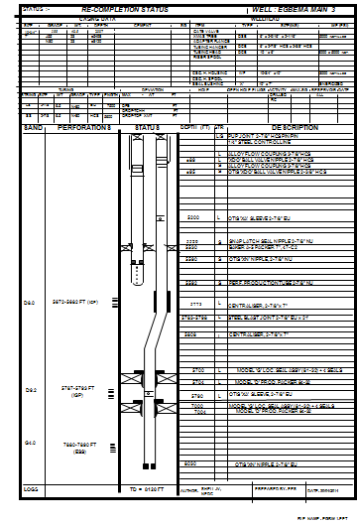
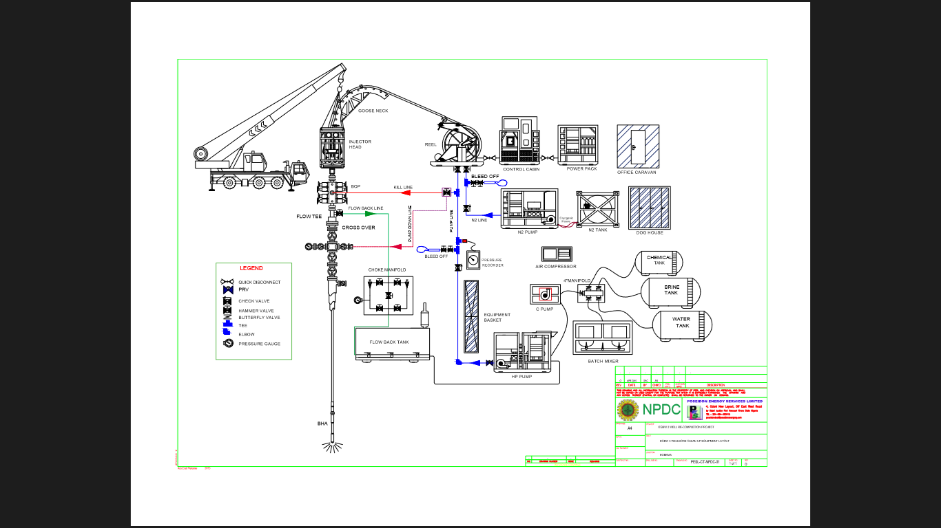
APPENDIX 2

